**Face Recognition using SURF with Back Propagation Neural Network**

Abstract— In this paper, a face recognition system for personal identification and verification using Back-propagation Neural Network is projected. The system consists of 3 steps. At the very beginning some pre-processing are applied on the input image. Secondly face features are extracted, which is able to be taken because the input of the Back-propagation Neural Network (BPN) within the third step and classification is carried out by using BPN. The projected approaches are tested on variety of face pictures. Experimental results demonstrate the higher degree performance of those algorithms.

1. **Introduction**

With the appearance of electronic medium, especially computer, society is more and keener about computer for processing, storage and transmission of data. Computer plays a crucial role in each elements of nowadays life and society in trendy civilization. With increasing technology, man becomes attached to the computer as the leader of this technological age and therefore the technological revolution has taken place everywhere the globe based on it.

It has opened a replacement age for mankind to enter into a replacement world, unremarkably called the technological world. Computer vision could be a part of daily life. One among the foremost important goals of computer vision is to attain visual recognition ability adore that of human.

Among several recognition subjects, face recognition has drawn extensive interest and a focus from several researchers for the last twenty years owing to its potential applications, like within the areas of surveillance, secure trading terminals, closed circuit tv (CCTV) control, user authentication, HCI Human computer  
Interface, intelligent automation & so on. Variety of face recognition strategies are projected and a few related face recognition systems are developed. In this paper we tend to propose a computational model of face recognition, that is quick, moderately easy, and correct in constrained environments like any workplace or a home. The proposed approaches have benefits over the other face recognition schemes in its speed and ease, learning capacity and relative inability to little or gradual changes within the face image.

1. **Outline of the System**

The issues of the design and implementation of the Face Recognition System (FRS) may be divided into 2 main parts. The primary half is image processing and therefore the second half is recognition techniques. The image process half consists of Face image acquisition through scanning, Image enhancement, Image clipping, Filtering, Edge detection and Feature extraction. The second half consists of the factitious intelligence that consists of Back Propagation Neural Network.

The primary part of FRS consists of many image processing techniques. The face’s image acquisition is achieved by a webcam, digital camera or using a scanner. Then the image clipping is performed using the start-point and end-point detection algorithm. The sides are detected using high-pass filter, high-boost filter, median filter or many edge detection techniques. The features are extracted, these extracted features of image are then fed into Back-propagation Neural Network.

In the second half, Technique used relies on Back propagation neural network. Within the initial techniques, the extracted features are saved into memory and using Back-propagation Neural Network; the recognition of unknown face image is performed by comparison this special pattern to the pattern for which an image module is already designed. A special advantage of the projected technique is that there's no further learning process enclosed here, solely by saving the face data of the person and appending the person’s name within the learned database completes the learning method. Within the second, extracted options are fed into the input of the Multilayer Neural Network and the network is trained to make a knowledge data base for recognition which is then used for recognition process. As the recognition machine of the system; a 3 layer neural network has been used that was trained with Error Back-propagation learning technique with a blunder tolerance of 0.001. Outline of the entire system is given in fig.1 shown below.

Store Weight and Threshold Value after Learning

Input Image

Face Image Enhancement

Surf Feature Extraction

Back propagation Neural

Network Learning

Use Learned Weights and C

Calculate the Output

Fig 1.Outline of the system

1. **System Development Methodologies**

As mentioned within the previous section, the system starts with acquisition of face image and ends with eminent recognition. This eminent notation comes through the application of a group of image processing, feature extraction and recognition techniques that are mentioned details within the resultant subsections.

1. **Face Image Acquisition**

To collect the face pictures, a scanner has been used. After scanning, the image can be saved into numerous formats such as Bitmap, JPEG, GIF and tiff. This FRS can process face images of any format. The face pictures we have used are taken from standard AT& T Face database

1. **SURF Features Extraction.**

SURF uses Hessian-matrix approximation operating on the integral image to locate the interest points, which reduces the computation time drastically. As for the descriptor, the first-order Haar wavelet responses in x and y directions are used in SURF to describe the intensity distribution within the neighborhood of an interest point. Only 64 dimensions are usually used in SURF to reduce the time cost for both feature computation and matching. Because each of SURF feature has only 64 dimensions in general and an indexing scheme is built by using the sign of the Laplacian, SURF is much faster.

1. **Recognition**

Extracted SURF features of the face pictures are fed in to the Back-propagation Neural Network for recognition. The unknown input face image has been recognized by Back-propagation Neural Network.

1. **Method adopted for Facial Features Detection**

There are some traditional algorithms for face recognition, which have been widely used in object detection and recognition. Among them the detector and descriptor, named Speed-Up Robust Features (SURF) suggested by Herbert Bay, attracts people’s attentions. SURF is a scale and in-plane rotation invariant detector and descriptor. In SURF, detectors are first employed to find the interest points in an image, and then the descriptors are used to extract the feature vectors at each interest point.

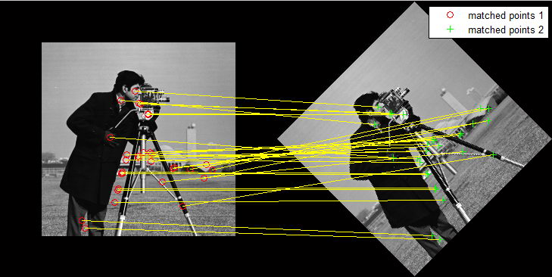

**Fig. 2 I/P using Surf Extraction Features**

1. **SURF Algorithm**

* Start Step 1: Input two images and extract the faces by using any face detection algorithm (e.g. Voila Zones).
* Step 2: Detect SURF feature points from the corresponding faces.
* Step 3: Extract SURF features.
* Step 4: Compare the SURF features of two images, find the matching points and calculate the matching percentage.
* Step 5: If the percentage is greater than a threshold the take the decision that the faces are matched. Otherwise reject the matching. Stop.

1. **SURF Feature Extraction**

SURF features can be extracted from images through SURF detectors and descriptors. Interest points are first extracted from each face image after pre-processing, such as normalization and histogram equalization. This turns out to obtain about 30-100 interest points per image.

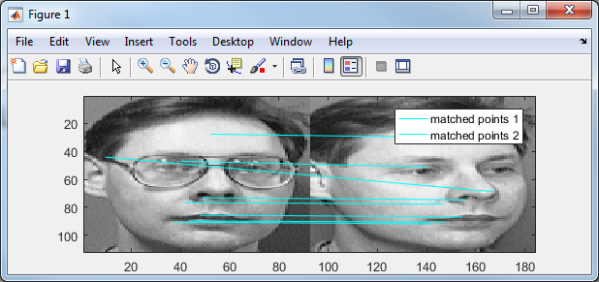

**Fig 2.1: Surf matching Points.**

The SURF feature vectors of the set of interest points are then computed to describe the image. These features are person-specific, since the number and the positions of points selected by SURF detector as well as the features around these points computed by SURF descriptor are different in each person’s image.

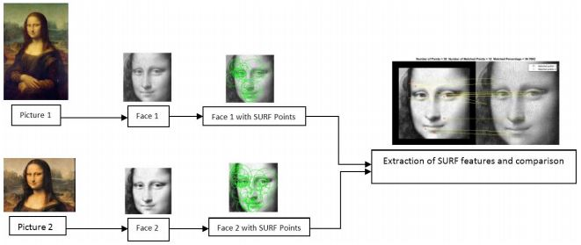

**Fig 2.2: Steps for face matching using SURF feature points**

In our proposed scheme we have compared two faces for matching. Firstly, we have calculated the SURF feature points on the two faces, which are also the ROI points of the same faces. Then we have extracted different features from the both face regions by using the feature points.

1. **SURF Feature Matching**

After SURF features have been extracted from images through SURF detectors and descriptors the features are matched against each other. We have calculated the matching percentage by using the following formula. Number of Matched Points Matching Percentage = x 100 Number of Interest points to take the decision if the two images are matched one threshold must be selected.

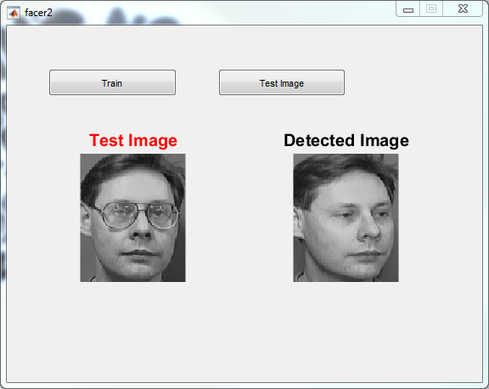

**Fig 2.3: Surf Detected Image Result**

1. **EXPERIMENTAL RESULT**

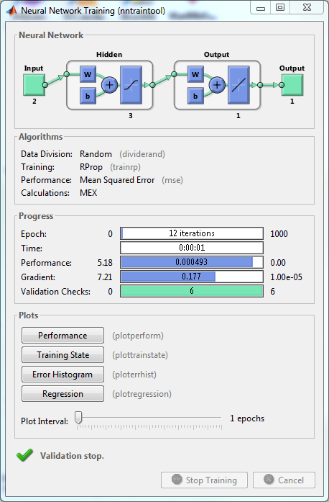

Fig 2.4 Output of Back Propagation Neural Network

Table I Results for BPNN using Quick Mask

|  |  |  |  |
| --- | --- | --- | --- |
| **No. of Face Image** | **Successfully recognized Face Image** | **Unrecognized Face Image** | **Efficiency %** |
| 5 | 3 | 2 | 60% |
| 13 | 9 | 4 | 69.23% |
| 20 | 15 | 5 | 75% |
| 22 | 16 | 6 | 72.72% |
| 25 | 18 | 7 | 72% |
| 30 | 25 | 5 | 83.33% |

Hence the efficiency of the Face Recognition System by using the Back Propagation Neural Network is 74.78%.

Table II Results for BPNN using Surf Features

|  |  |  |  |
| --- | --- | --- | --- |
| **No. of Face Image** | **Successfully recognized Face Image** | **Unrecognized Face Image** | **Efficiency %** |
| 5 | 4 | 1 | 80% |
| 13 | 12 | 1 | 92.30% |
| 20 | 19 | 1 | 95% |
| 22 | 20 | 2 | 90.90% |
| 25 | 24 | 1 | 96% |
| 30 | 28 | 2 | 93.33% |

Therefore the potency of the Face Recognition System by using Back-propagation algorithm using SURF Features is 93.04% which is why BPN is best as delineated in fig.9.

1. **CONCLUSION**

In this present thesis, a model of Face Recognition System using the Step Error Tolerance Back-propagation Neural Network and digital image processing has been mentioned. Here a static Face Recognition system has been developed. The most efficiency is 82.61% for Face Recognition System by using Quick Mask and therefore the most potency is 91.30% for Face Recognition System by using BPN with SURF. The potency can be accrued by using better face scanner, better technique of scaling, and efficient technique of edge detection such as advanced edge detection technique and feature extraction of the face image.